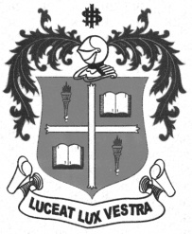
LOYOLA COLLEGE (AUTONOMOUS), CHENNAI – 600 034
M.A. DEGREE EXAMINATION - APPLIED HISTORY
FIRST SEMESTER – APRIL 2012

HT 4813/1811 - HISTORY OF MODERN SCIENCE

Date : 03-05-2012 Dept. No. Max. : 100 Marks

Time : 9:00 - 12:00
PART – A

Answer any Four of the following in about 100 words each: (4 x 5 = 20 Marks)

- Copernichus
- Indian Railways
- Botonical investigation
- Indian Medical Services
- J.S. Bose
- James Watt
PART – B

Answer any Two of the following in about 200 words: (2 x 10 = 20 Marks)

- Assess the role of Missionaries in the promotion of Indian science.
- Write a short on Meterorology.
- Estimate the contribution of Chandrasekar to Astrophysics
- Briefly explain the various programmes of Central Leather Research Institute.

PART – C

Answer any Three of the following in about 1200 words: (3 x 20 = 60 Marks)

- Analyse the Significance of scientific revolution in the west.
- Trace the growth and development of Indian Science under the British.
- Estimate the Career and Achievements of Sir C.V. Raman.
- Describe the Objectives and Activities of DRDO.
- Assess the role of M.S. Swaminathan in the Green Revolution.

**********

